**NAME---HARSH KUMAR**

**ID---B219027**

**BRANCH---CE-4TH SEM.**

**DATE--- 29-01-2021**

LAB-3

1. **SELECT - FROM -GROUP BY:** This query is used to group to all the records in a relation together for each and every value of a specific key(s) and then display them for a selected set of fields the relation.

* + *Syntax: SELECT a set of fields FROM relation name GROUP BY fieldname.*
  + *Example: SQL> SELECT CID, SUM (PRICE) FROM CUSTOMER GROUP BY ITEMNAME.*

# EXAMPLE 1 & 2:

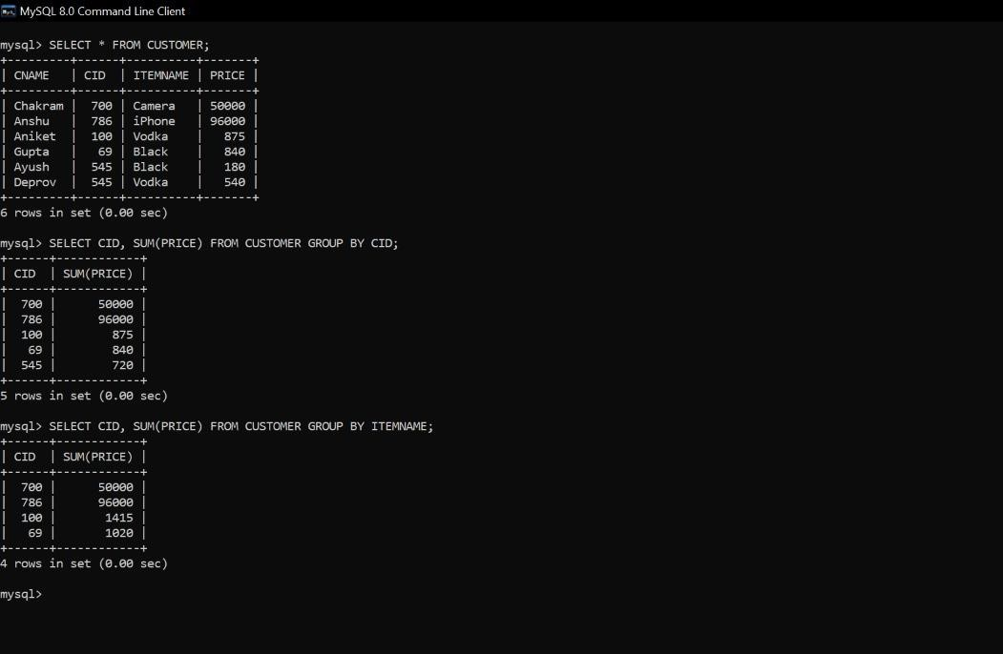

1. **SELECT - FROM -ORDER BY:** This query is used to display a selected set of fields from a relation in an ordered manner base on some field.

* *Syntax: SELECT a set of fields FROM relation name ORDER BY fieldname.*
* *Example: SQL> SELECT SNAME, SUBJ1 FROM STUDENTS ORDER BY ROLL.*

# EXAMPLE 1 & 2:

# 

1. **JOIN using SELECT – FROM- WHERE:** This query is used to display a set of fields from two relations by matching a common field in them.

* *Syntax: SELECT a set of fields from both relations FROM relation_1, relation_2 WHERE relation_1.field_x = relation_2.field_y ;*
* *Example: SQL> SELECT * FROM FACULTIES, STUDENT WHERE STUDENT.SNAME = FACULTIES.FNAME*

# EXAMPLE 1 & 2:

# 

1. **JOIN using SELECT –FROM- WHERE- ORDER BY:** This query is used to display a set of fields from two relations by matching a common field in them in an ordered manner based on some fields.

* *Syntax: SELECT a set of fields from both relations FROM relation_1, relation_2 WHERE relation_1.field_x = relation_2.field_y ORDER BY field_z;*
* *Example: SQL> SELECT * FROM FACULTIES, STUDENT WHERE STUDENT.SNAME = FACULTIES.FNAME ORDER BY ROLL*

# EXAMPLE 1 & 2:

